Materials Science WS #1
Molecular Orbital Theory

1. a.) Draw an energy level diagram for the H₂⁻¹ ion.

b.) Write the electron configuration of the ion in terms of its MOs.

c.) Calculate the bond order in H₂⁻¹

d.) Suppose that the ion is excited by light, so that an electron moves from a
lower-energy to a higher-energy molecular orbital. Would you expect the excited-state H₂⁻¹ ion to be stable or to fall apart?

2. Which of the following ions would you expect to be diamagnetic: N₂⁻², O₂⁻². Be₂⁺²,
C₂⁻¹

3. If we assume that the energy-level diagrams for homonuclear diatomic molecules
shown in Figure 9.43 can be applied to heteronuclear diatomic molecules and ions,
predict the bond order and magnetic behavior of:
a.) CO⁺¹
b.) NO⁻¹
c.) OF⁺¹
d.) NeF⁺¹

4. Carbon monoxide, CO, is isoelectronic to N₂.
a.) Draw a Lewis structure for CO that satisfies the octet rule.
b.) Assume that the diagram in Figure 9.49 can be used to describe the MOs of
CO. What is the predicted bond order for CO? Is this answer in accord with
the Lewis structure you drew in part a.)?
c.) Experimentally, it is found that the highest-energy electrons in CO reside in a
σ-type MO. Is that observation consistent with Figure 9.49? If not, what
modification needs to be made to the diagram? How does this figure relate to
Figure 9.45?

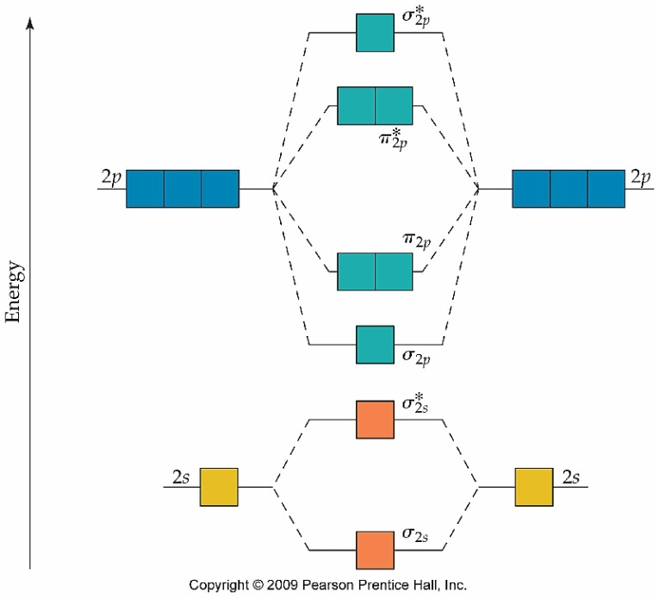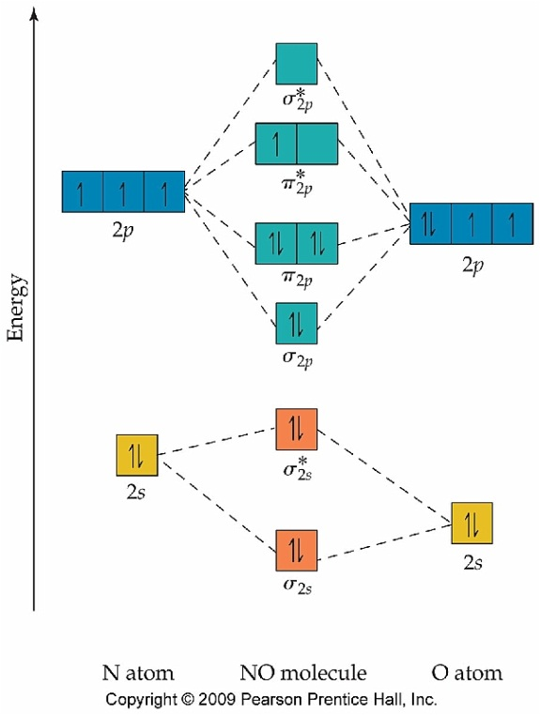

Figure 9.49
Figure 9.43

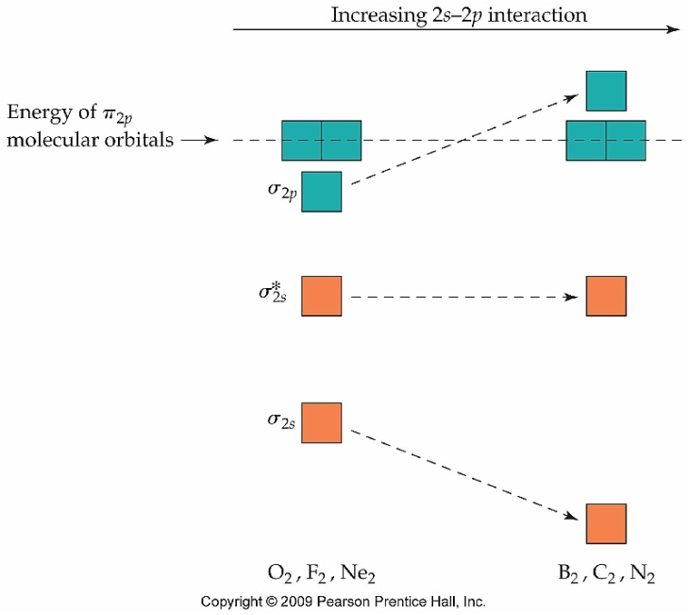
Figure 9.45
Figure 9.45

